# Data Preparation

The aim of our study was to understand the different transport profiles that are seen across England our Wales. Therefore, in terms of data for the initial clustering algorithms. our aim was to find as much transport information we could. This was primarily undertaken at the MSOA level given that this is the lowest UK geographic level for which relevant transport data could be found. Therefore, the datasets collected were such that these would provide us with an idea of how different groups of people commute in England and Wales commute. This includes those shown in table X below, which provides a brief description of each dataset along with the source from which it was obtained.

|  |  |  |  |
| --- | --- | --- | --- |
| **No.** | **Dataset** | **Description** | **Source** |
| 1 | Public Transport stops | The Geographical Location of all Bus, Tube and Railway stop in the UK | Data.gov (DfT 2014) |
| 2 | Car Ownership | Number of households owning 0, 1, 2, 3 and 4 or more cars in each MSOA | Nomis official labour market statistics (nomis 2013), from 2011 census |
| 3 | Commuter Flow Data | The number of people commuting between all MSOA pairs, disaggregated by mode of travel | 2011 census (nomis 2011) |
| 4 | Travel Time Data | Travel time between all MSOA pairs using bus, rail, and car | Quant Project, CASA (Batty and Milton 2019) |

The 1st dataset on public transport stops is a csv containing latitude and longitude values for all transport stops in the UK. From this our primary concern was for bus stops, train stations and tube/tram/metro stations in England and Wales. To obtain the information in terms of the number of different stops within each MSOA, this was merged with a shapefile of the UK MSOAs and a points in polygon analysis was performed in R Studio, as can be seen in figure X. The results from this were then used to create a new data frame that was outputted to a CSV that could later be merged with the other data.

Figure 1 ­- Showing the points of all a) bus stops, b) tram/metro and underground stations and c) all train stations across England and Wales

The 3rd dataset contains travel to work data from one MSOA to another in the form of Origin – Destination pairs for each travel mode , as shown in Fig X.

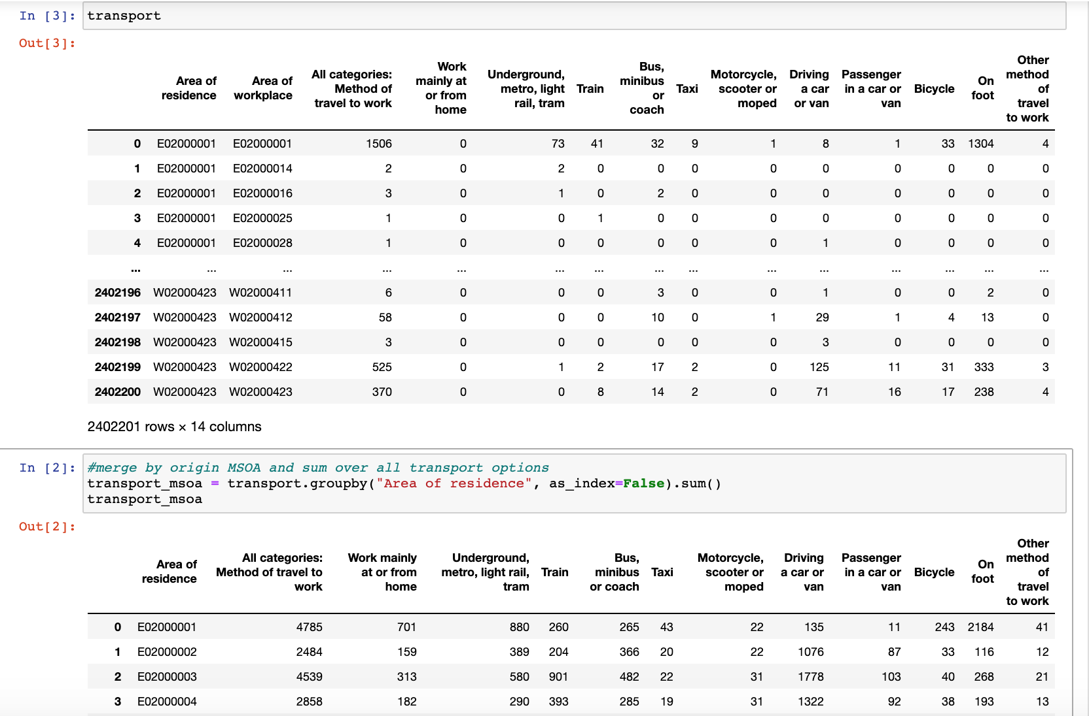

Figure : Commuter Flow Data from 2011 Census (MSOA level)

To transform the data to get information about each individual MSOA and their transport use, this data was grouped by area of residence and the sum for each transport mode was calculated (fig X). This allows us to get the variation in mode share per MSOA. These sums were then turned into % to allow for comparison between MSOAs.



Figure 2: Commuter Flow Data Grouped by Area of Residence

The 4th dataset was used to compare [1] the relative accessibility and [2] actual commuting patterns of the different MSOAs.

1. For each MSOA, we calculated the average travel time to all other MSOAs by mode. For example:
2. We join the commuter flow data with the travel time data to get the actual average travel time by mode of the trips originating at each MSOA

As a result of this the following variables, as shown in table X, could be measured for each MSOA. The data was subsequently merged into one dataset (all_transport_data.csv) so that we could conduct our cluster analysis.

|  |  |
| --- | --- |
| Variable (MSOA level) | Description |
| Bus_stops | No. of Bus stops |
| Train_stations | No. of train stations |
| Metro_station | No. of tube stations |
| HH_owning_cars_perc | The % of households owning at least 1 car |
| work_from_home_perc | % of MSOA residents who work from home |
| underground_metro_perc | % of MSOA residents who use each of these modes for their commute (the mode assigned to a person is the one that makes up the largest portion of the trip) |
| car_perc |
| train_perc |
| bus_perc |
| taxi_perc |
| motorcycle_perc |
| bicycle_perc |
| on_foot_perc |
| other_perc |
| avg_time_from_origin_car_UNWEIGHTED | Calculated using Equation (X) |
| avg_time_from_origin_bus_UNWEIGHTED |
| avg_time_from_origin_rail_UNWEIGHTED |
| avg_time_car | Calculated using Equation (Y) |
| avg_time_bus |
| avg_time_rail |

# Data Transformation & Standardization

Before clustering could be performed on the data it is noted the algorithms used, of K-Means, DBSCAN and Hierarchical clustering are sensitive to the initial inputs to the extent that different units, scales and variations are likely to influence to the outcomes. Therefore, the data must be cleaned, transformed and standardized prior to performing these algorithms. In this sense, we considered the methodology used by the Office for National Statistics to classify output areas (Office for National Statistics 2015). This included [1] transforming the variables and then [2] standardizing them. The ONS start off with 167 variable which they reduce to 60 by trying different variable transformation and standardization combinations and eliminating correlated variables. Our analysis was similar, but we start off with only 20 variables, and eventually settle on 14. One major variation of our work is we apply 3 different clustering algorithms, whereas the ONS only apply 1. We therefore end up comparing different (transformation + standardization + clustering) combinations and use visual inspection and variable distribution of clusters to settle on the combination that we consider to be the best representation of reality. The steps of our work are outlined below.

## Transformation

Initial exploration of the variable distribution showed that many of the variables were skewed to some degree (Figure X). Using skewed data in clustering analysis is likely to results in clusters that are not reflective of the true underlying groups of data because extremes and outliers will likely influence the way in which groups are formed, especially for those using distance based metrics such K-Means (Kumar, et al., 2015). To control for this the data is transformed prior to standardization to reduce the potential adverse effects on the clustering algorithm. However, since each variable is not skewed to the same degree, or necessarily in the same direction, then three different transformations were applied to the data for which the outcomes and results could be compared. This includes log transformation and Yeo Johnson transformation to obtain more normally distributed variables. In addition to this the ONS used a box-cox transformation, but this does not work when there are zeros in the data, and so we used the Yeo Johnson transformation as it can handle zeros (Yeo and Johnson 2000).

Original Variable Distributions

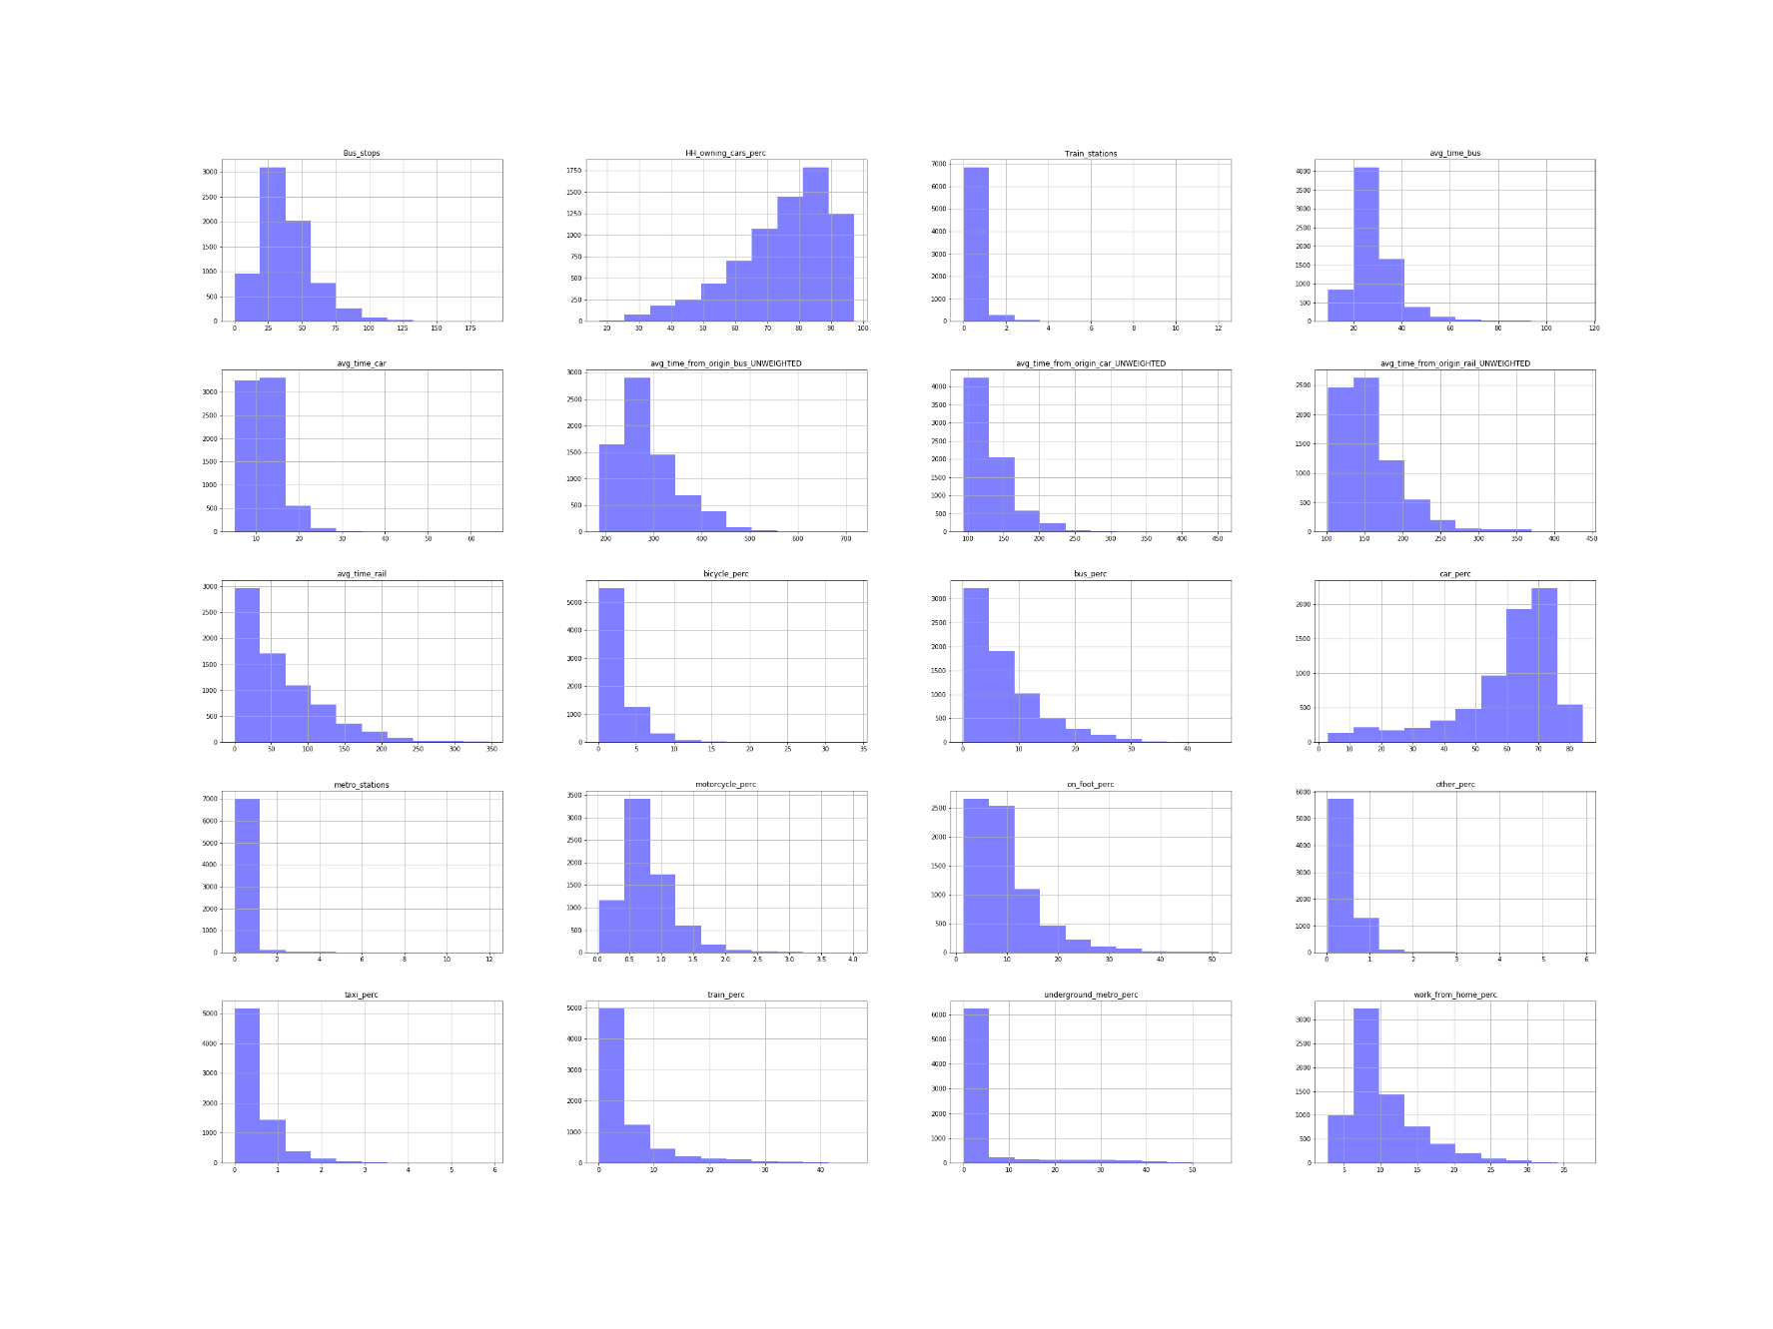

Figure 3: Original variable distributions

Both transformations resulted in more normal distributions for most of the variables, but not all of them. An example is the distributions of unweighted travel times for all bus, rail and car after the Yeo-Johnson transformation (figure 2).

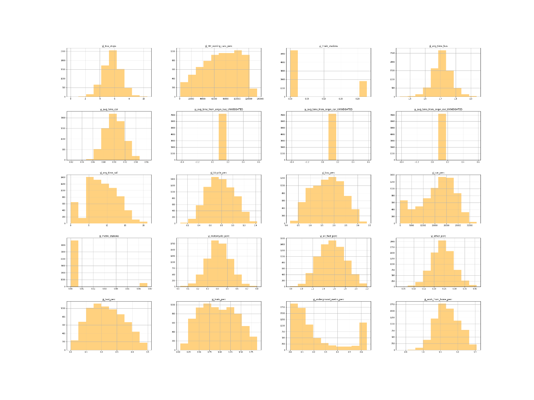

Figure 2: Variable distributions after Yeo-Johnson transformation

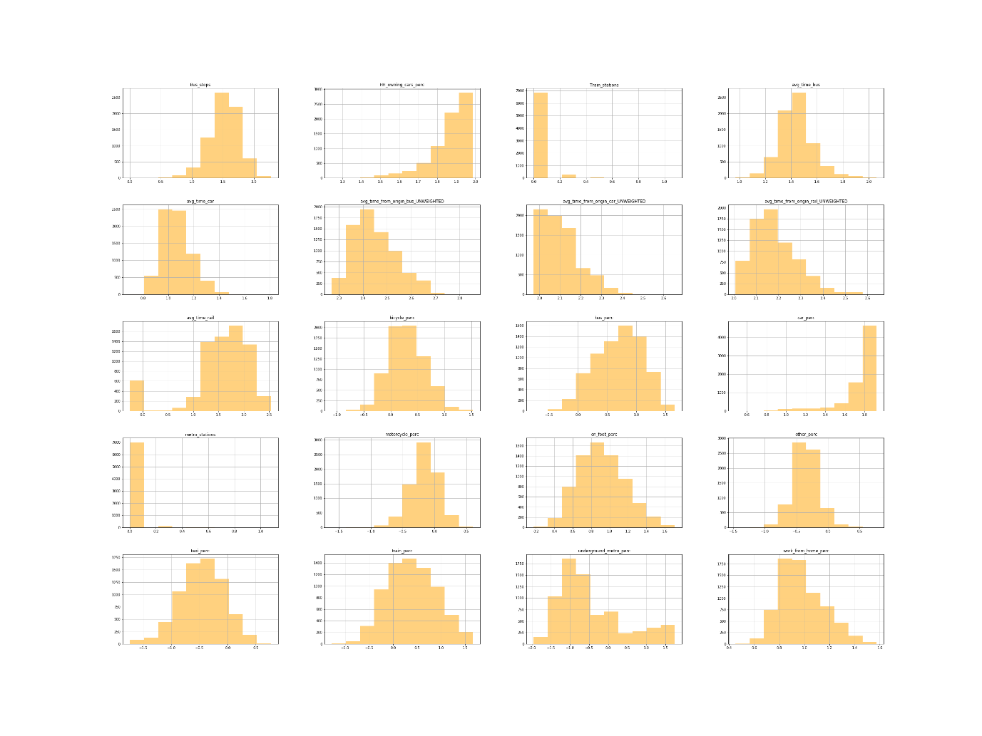

Figure 3: Variable distribution after log transformation

## Standardization

The variables we were using had different units and ranges. We tried to have as many variables as possible in the same units but that was not possible for all values and therefore there were discrepancies in units and ranges for each of the variables. (An example would be travel time which cannot be changed into %). This is an issue with clustering since variables with the largest size or variability have the biggest influence on the clustering algorithm, especially k-means (Bin Mohamad and Usman 2013). Data standardization is carried out to adjust the relative weight of the variables to avoid this issue (Milligan and Cooper 1988). Standardization rescales all of the variable so that they are within the same range, thereby preventing large-scaled variables from having a bigger influence on the clustering algorithms

The standardization technique used normally depends on the distribution of the data, but since there was no consistent distribution of variables in either transformation, we carried out three different standardization techniques on our transformed data. This allowed us to compare the cluster outputs resulting from different transformation + standardization combinations. The following standardization techniques were used:

### z-score

The resulting values show many standard deviations each value is from the mean. The mean is 0 and negative values are those smaller than the mean.

### Range

All variables are standardized to have values between 0 and 1

### Inter-decile range (IDR)

IDR standardization is more suited to data with extreme outliers than range standardization as it uses the 10th and 90th percentile instead of the maximum and minimum values.

# Data Analysis

## Clustering

We use three different clustering algorithms and compare the results:

### k-means

### hierarchical (agglomerative)

### DBSCAN

These algorithms differ in their underlying assumptions, and so naturally they produce different results. Both *k-means* and *hierarchical clustering* require specifying the number of clusters beforehand. This was done using elbow plots and silhouette scores. Elbow plots are based on minimizing the Within-Cluster Sum of Squares (WSS). The higher the number of clusters, the lower the WSS, as the variation becomes 0 when the number of clusters is equal to the number of points. The elbow method ensures that we do not overfit to the data by choosing a number of clusters after which the improvement is marginal.

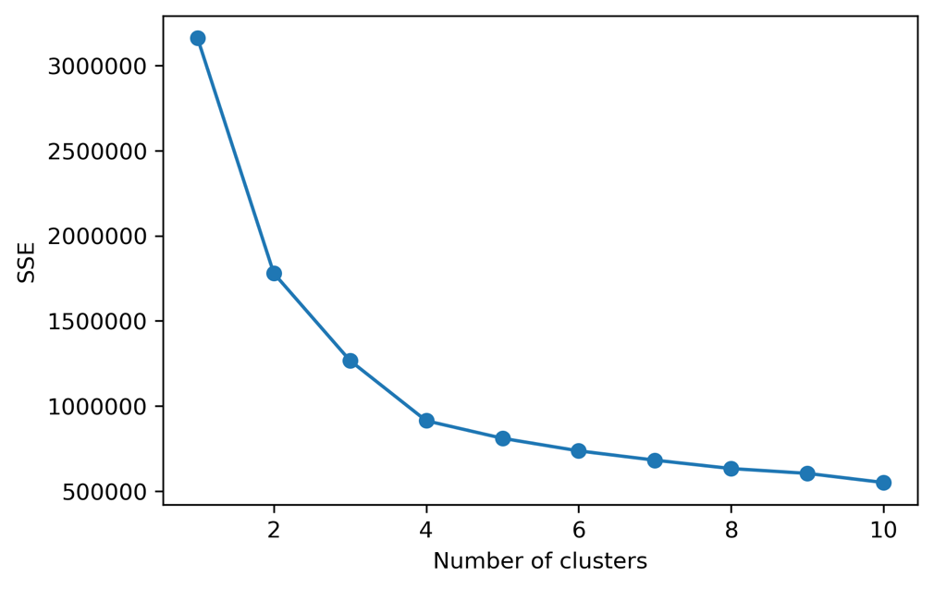

Figure X: elbow plot for log-idr-kmeans

Silhouette scores give us an indication of how compact and separated from each other the clusters are (Chen et al. 2002). The closer points in a cluster are to each and the further away they are from points in the nearest cluster, the better the silhouette score. Comparing silhouette scores allows us to choose the best number of clusters.

The two methods measure different things and so did not always give the same results. We therefore used them for guidance but ended up selecting the number of clusters that provided results which made sense.

DBSCAN is a density-based clustering algorithm where clusters are formed if a minimum number of points are within a given distance (ε) of each other. Unlike, k-means and hierarchal clustering, DBSCAN highlights outliers and does not add all points to clusters. It does not perform well when the data has clusters of different densities, as ε cannot be calibrated to suit different clusters.

Since we do not know the relationship between our points in high-dimensional space, we ran the 3 different clustering algorithms and compared the results

In total we have 2 transformation techniques, 3 standardization techniques and 3 clustering techniques, leading to 18 combinations of results. We analyze the results of all 18 combinations and check the histograms of each to see the distribution of MSOAs to clusters in each of the 18 results.

For example, DBSCAN consistently failed to assign MSOAs to reasonable clusters, with all results showing the majority of MSOAs assigned to 1 cluster and the rest identified as outliers. This can be attributed to the ‘curse of dimensionality’, where the distance between different pairs of points decreases as the number of dimensions increases (Steinbach, Ertöz, and Kumar 2004). As DBSCAN works by grouping points within a certain radius of each other, slight variations in that radius has a big effect on the number of points included when dealing with high-dimensional data.

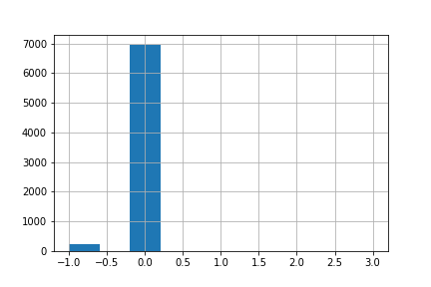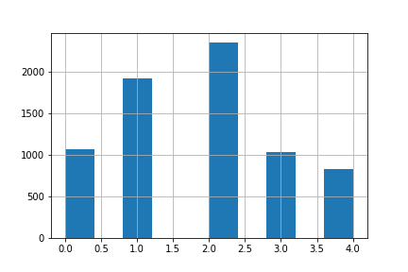

Figure X: Histograms showing Number of MSOAs assigned to each cluster. LEFT (log_range_DBSCAN) &) RIGHT (log_range_kmeans)

K-means and Hierarchal clustering algorithms provided better results, which were compared by looking at the variable distribution of each cluster and maps of the clustering results to see if they made sense or not.

## Variable Selection

To improve interpretability of results, we decided to remove some variables and redo the cluster analysis. Variables that were highly correlated (i.e. motorcycle percentage) were removed.

After further inspection of the clusters we saw that some variables did not appear to influence the clustering results. Therefore, we removed variables in sequence to see what affect, if any, they had on the clustering results. The first step was to remove other and taxi (commuter mode shares). The results appeared to be unaffected and had improved interpretability. Then the number of bus stops, train stations, and metro stations was removed. Even though the last three variables appear intuitively to be of great importance, we hypothesized that they were not having an effect because the accessibility scores by mode were making them redundant.

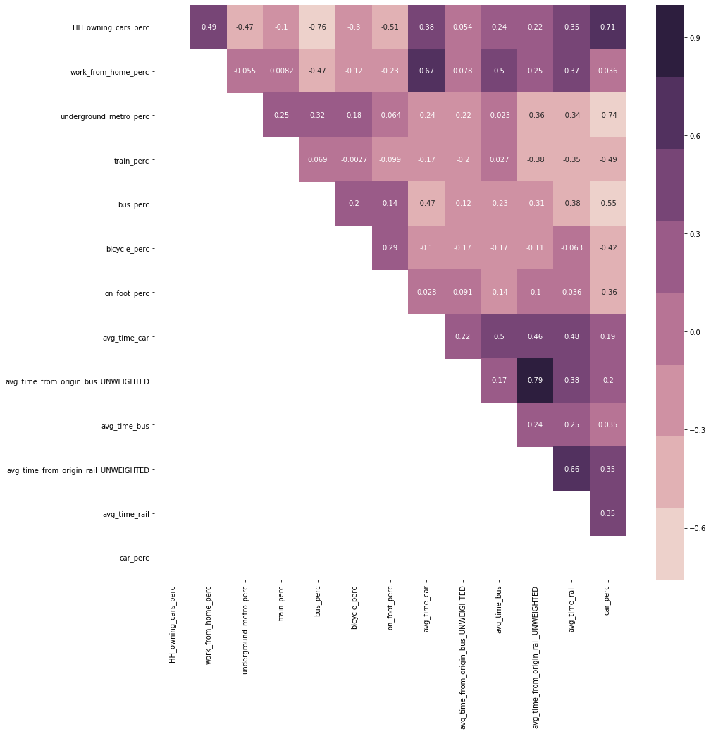

Figure X: Correlation of variables used to produce clustering results

## Comparing Results

Evaluation of our initial clustering results enabled us to filter down the initial 20 variables to 14. We then reran our clustering algorithms with the 14 variables and ended up with another 18 results. In following similar steps, we removed the results which had a skewed distribution in the number of points assigned to each cluster, did not appear to represent geographical reality and did not appear to produce meaningfully distributed clusters. The result we decided that best represented differentiation in clusters and mapped onto our knowledge of existing geography in the UK was the:

log (transformation) -> z-score (standardization) -> kmeans (clustering)

The resulting output was 5 clusters with distinct combinations of variable characteristics, as can be seen from the variable averages in each cluster (Figure X) with descriptions of each cluster given in figure X

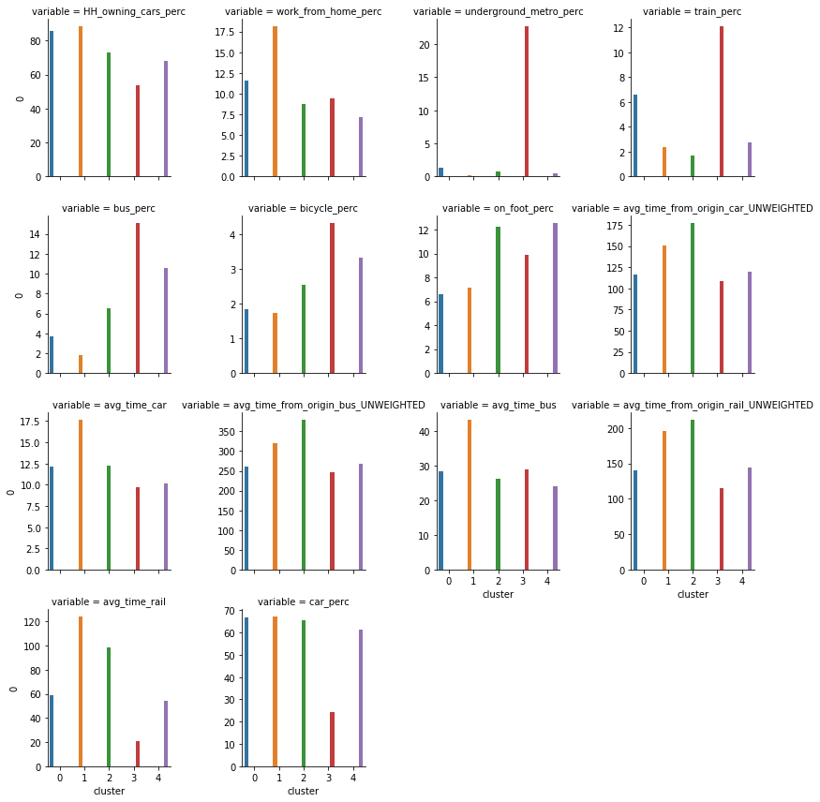

Figure X: Variable averages in each cluster

Table X: Cluster Descriptions

|  |  |  |
| --- | --- | --- |
| ***Cluster*** | ***Plot Color*** | ***Extended Description*** |
| 0 | Blue | **Good train accessibility but car dependant**: The cluster is composed of rural areas that surround land-locked urban areas. They are mainly in the center of the UK, compared to rural areas in cluster 2 which are on the outskirts. This central location is reflected in their relatively better accessibility scores across all transport modes with the second best accessibility scores for these. The clusters benefit from being on train routes with the second highest train usage but that is the only mode of public transport that they are serviced by. As a result, the cluster is associated with high car ownership and usage, followed by train and walking. |
| 1 | Yellow | **Solely car dependant**: The cluster is made up of rural areas far from the cities. They have no public transport options and people depend on cars to move around. They have poor accessibility even by car, and this could be due to a lack of direct road connections between them and other parts of the country. The cluster is found on the periphery of cluster 2, which is itself made up of coastal cities (like Newcasle and Cornwall) with poor accessibility |
| 2 | Green | **Lack of accessibility across all Transport modes -** This cluster shows the third highest usage of bus, bicycle and walking to work, but has the lowest train usage, working from home and all around accessibility. The most popular modes to travel to work are by car, by walking and bus but the lack of accessibility across all modes and little train usage is the defining feature. This can be found in coastal towns and cities such as Newcastle, Cardiff and Blackpool which might suggest they are at the end of train lines and other transport networks and therefore lack connectivity apart from internal bus usage. |
| 3 | Red | **High public transport and good accessibility** - The cluster is associated with high usage of public transport including the underground/metro/tram, train and bus. It is noted to have very good accessibility to all MSOAs through all transport modes therefore highlighting the ability of people to easily move around. This cluster dominates London, but can also be found in the centre of some MSOAs in big cities like Manchester and Birmingham. The cluster suggests that the transport profile of London is different to the rest of the UK and can only otherwise be found in high accessibility centres of large cities. |
| 4 | Purple | **Car reliant but high public transport** - This cluster has high car usage but is notable for the large number of people who use the bus and walk to work. These MSOAs also have a high degree of accessibility but the overall transport profile is more shifted towards cars than the previous cluster. This is found in large Urban areas across the UK such as Manchester and Birmingham, suggesting that the main differnece between these and London is the degree of usage of public transport with the main difference occuring due to the lack of usage of an underground/metro/tram. |

## Classification

The next step was to run a classification analysis in order to determine which demographic characteristics are related to each transport profile (as identified by our clusters). In other words, are the variations in transport characteristics part of a larger socioeconomic divides across the UK. Previous research i.e. (Titheridge, et al., 2008), (Pinjari, et al., 2007), (Ferdous, et al., 2011) suggests that demographic characteristic such as income, unemployment, education level and sex can influence transport travel mode choice. Therefore, based on available data at the MSOA level, the following variables (Table X) were chosen to understand how they are related to the transport profile classes that we identified

Table X: Variables used in Classification

|  |  |  |
| --- | --- | --- |
| **Dataset** | **Description** | **Source** |
| Net annual income (£) | Average net annual income in 2018 | Office for National Statistics (ONS 2020) |
| Pop_Per_Hectare | Population density | Office for National Statistics (ONS 2019) |
| percent_unemployed |  | 2011 Census (nomis 2011) |
| percent_at_or_above_qual_  level_4 | The % of people living in the MSOA that achieved Qualification Level 4 or above |
| perc_households_owned | The % of households in the MSOA that are owned |
| avg_number_of_bedrooms |  |
| perc_bad_health | The % of residents who suffer from bad or very bad health |
| perc_employed_females_  working_fulltime | The % of the labor force that is made up of employed females working >35 hours per week |
| mean_age |  |
| perc_christian |  |
| perc_non_religious |  |

A Random Forest classification with 100 trees and no pruning was done. Oshiro, Perez, and Baranauskas (2012) note that beyond a certain threshold of trees, there is no improvement in model performance, and suggest a value between 64 and 128. Pruning is done in decision trees to avoid over-fitting. This is not necessary in random forest which use random selection of features and so produces different trees that are not correlated with each other (Breiman 2001).

### Results

Table X: Random Forest Results

|  |  |  |  |
| --- | --- | --- | --- |
|  | precision | recall | f1-score |
| 0 | 0.83 | 0.52 | 0.64 |
| 1 | 0.59 | 0.07 | 0.12 |
| 2 | 0.77 | 0.76 | 0.76 |
| 3 | 0.60 | 0.81 | 0.69 |
| 4 | 0.62 | 0.81 | 0.70 |
|  |  |  |  |
| accuracy |  |  | 0.65 |
| macro avg | 0.68 | 0.59 | 0.58 |
| weighted avg | 0.66 | 0.65 | 0.60 |

The accuracy score shows that 65% of MSOAs are classified correctly by the model. The precision value shows that the model was prone to false positives, particularly with cluster 1, 3, and 4. The recall score shows that the model was unable to give the correct value for cluster 1, meaning that most MSOAs in cluster 1 were misclassified. The confusion matrix (Figure X) shows that only 19 out of 284 MSOAs in cluster 1 were correctly classified.

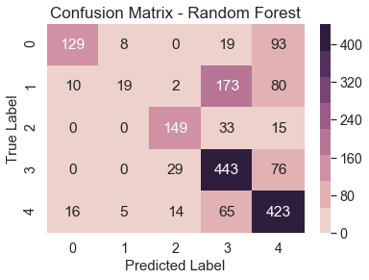

Figure : Confusion Matrix for Random Forest Classification

### Feature Importance

To understand which variables were most related to transport characteristics, we use feature importance. The default feature importance, which is based on gini impurity, is biased, especially when variables vary in scale; continuous and high cardinality variables (variables with many unique values) tend to rank higher even if they are no more informative than other variables (Strobl et al. 2007). We opted for permutation importance (Altmann et al. 2010) as it is less biased in its interpretation of feature importance than the default sklearn feature importance.

The importance is based on calculated the coefficient of determination (R2), randomly reshuffling one variable, then recalculating R2. The decrease in model performance (difference in R2) is a measure of the variable’s importance.

We added a random variable to the model to see if any variable performed worse than it, but none did. Population density is the most important feature (Figure X), which is not surprising given that public transport is mostly associated with urban agglomerations. Religious variables, unemployment rate have little predictive power, indicating that they may show uniform distribution across the study area